Use Case Specification

DMT/RM01/TMP

|  |  |
| --- | --- |
| Project Code | PROJECT_AMS_Raise_a_Request |
| Project Name | Asset Management System |

|  |  |  |
| --- | --- | --- |
| Prepared/Modified by | Role | Date of Preparation |
| Rashmi | Test Engineer | 27/09/2018 |
| Reviewed by | Role | Date of Review |
| Sapna | SME |  |
| Approved by | Role | Date of Approval |
| Pranav | Test Manager |  |
| Circulation List |  | Version Number of the template: |
| Version Number | 1 |  |

<<Customer>> REVIEW HISTORY

<<Customer comments on the Use case along with the signed off is tracked here>>

|  |  |  |  |  |  |  |
| --- | --- | --- | --- | --- | --- | --- |
| Version | <<Version number>> |  |  |  |  |  |
| Date | <<Date of Review>> |  |  |  |  |  |
| Reviewed by | << Reviewer Name>> |  |  |  |  |  |
| Reviewed UI Specification doc | << Whether UI Specification doc is reviewed >> |  |  |  |  |  |
| All Open Queries/issues closed | << Whether all the open queries and issues resolved>> |  |  |  |  |  |
| Agreement on Assumptions | <<Whether all the assumptions have been agreed upon by the customer>> |  |  |  |  |  |
| Sign Off | <<Signature>> |  |  |  |  |  |

Disclaimer:

The scope of the project ‘<<Project Name>>’ is restricted to the contents of this signed off use case.

TABLE OF CONTENTS

1.Use Case Name: <<Use Case Name>> 4

2.Actor(s) 4

3.Preconditions 4

4.Flow of Events 4

4.1 Basic Flow 4

4.2 Alternative Flows 5

4.2.1 Alternate Flow 1 5

4.3 Sub Flows 6

4.3.1 Sub Flow 1 6

5.Post Conditions 6

6.Special Requirements 7

7.Extension Points 7

<Name of extension point> 7

8.Business Rules 7

9.Diagrams 8

Use Case Diagram 8

Activity Diagram 9

10.Scenarios 10

Success Scenarios 10

Failure Scenarios 10

11.Issues 10

12.UI Specifications 10

13.Inter System Dependencies 11

14.Integration with an already existing System of the <<Customer>> 11

15.Assumptions 11

REVISION HISTORY OF THE WORK PRODUCT…………………………….. .. 12

Use Case Name: Asset Management System

Use Case ID: Asset Management System Website

1.0

**Brief Description**: For Manager, this screen is available to raise a requests of assets

Actor(s)

1.Manager

2. Asset Management Sysytem

Preconditions.

1. Website should be accessible by the manager by visiting the website on the browser
2. The person logging in for Asset Management System should be manager.

Flow of Events

4.1 Basic Flow

**Name:** Successful Raise a Request in Asset Management System

1. Manager login into the website
2. Manager clicks on Raise Request link
3. Manager selects EMP NO
4. Manager selects Asset Name
5. Manager enters description
6. Manager enters quatity
7. System displays the message “Successfully Raised a Request”

Exception Flow 1: unsuccessfull Raise Request in Asset Management System due To invalid Range

1. Manager login into the website
2. Manager clicks on Raise Request link
3. Manager selects EMP NO
4. Manager selects Asset Name
5. Manager enters description
6. Manager enters quatity
7. System displays the message “Please enter quantity in valid range”

Exception Flow 2 :unsuccessful Raise Request in Asset Management System due to invalid Description

1. Manager login into the website
2. Manager clicks on Raise Request link
3. Manager selects EMP NO
4. Manager selects Asset Name
5. Manager enters description
6. Manager enters quatity
7. System displays the message “Please fill below 25 characters ”

Exception Flow 3 :unsuccessful Raise Request in Asset Management System due to Web Server Down

1. Manager login into the website
2. Manager clicks on Raise Request link
3. Manager selects EMP NO
4. Manager selects Asset Name
5. Manager enters description
6. Manager enters quatity
7. System displays the message ” Web Server Down”

Exception Flow 4 :unsuccessful Raise Request in Asset Management System due to Database Connectivity Error

1. Manager login into the website
2. Manager clicks on Raise Request link
3. Manager selects EMP NO
4. Manager selects Asset Name
5. Manager enters description
6. Manager enters quatity
7. System displays the message ” Database Connectivity Error”

Exception Flow 4 :unsuccessful Raise Request in Asset Management System due to Network Connectivity Error

1. Manager login into the website
2. Manager clicks on Raise Request link
3. Manager selects EMP NO
4. Manager selects Asset Name
5. Manager enters description
6. Manager enters quatity
7. System displays the message ” Network Connectivity Error”

Post Conditions

| Flow Name | Post Condition |
| --- | --- |
| Successful Raise Request in Asset Management System | System displays the message “Successfully Raise Request” |
| Unsuccessful Raise Request in Asset Management System due to invalid range of quantity | System displays the error message “Please provide quantity within the range” |
| Unsuccessful Raise Request in Asset Management System due to invalid description | System displays the error message “Please fill below 25 characters” |
| Web Server Down | The system should display an error message to the user regarding web server unavailability problem. |
| Database Connectivity Error | The system should display an error message to the user regarding the database connectivity problem. |
| Network Connectivity Error | The system should display an error message to the user regarding the network connectivity problem. |

Special Requirements

Performance

The Manager should receive a mail regarding all the details entered after successfully Raised the Request.

Availability

* 1. Application is up and running 24*7.

Business Rules

| Business Rule Name | Business Rule Description | System action (if BR fails) |
| --- | --- | --- |
| BR01 | All fields must be selected | Error message is displayed if any field is not selected |
| BR02 | Valid no of quantity must be entered | Error message is displayed if invalid |
| BR03 | All the data entered should be less than 25 characters | Error message should be displayed if invalid data is entered |

Diagrams

Use Case Diagram

* 1. For Successful Asset Management System
     1. Admin

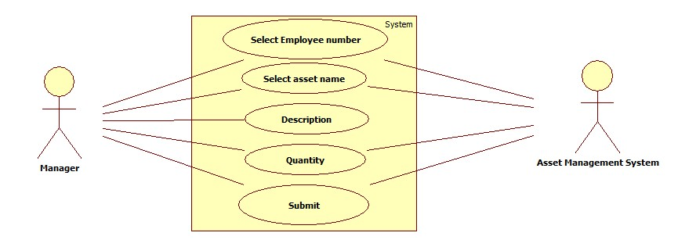

Scenarios

Success Scenarios

* Successfully raised request in Asset Management System

Failure Scenarios

* Failed Login in Asset Management System for entering invalid range in Quantity
* Failed Login in Asset Management System for not entering characters less than 25

Issues

1. What is to be done if web server is down?
2. What is to be done if the Raise Request link does not get opened?
3. What is to be done if there is data connectivity error?
4. What is to be done if the form is not getting submitted even after entering valid field details without any alerts for errors?

Assumptions

1.Manager can easily raise a request.

2.The Manager selected and entered all the fields.

REVISION HISTORY OF THE WORK PRODUCT

<to be maintained by projects>

|  |  |  |  |  |  |
| --- | --- | --- | --- | --- | --- |
| # | Date | Version # | Section Changed | Details of changes made | Approved By |
| 1 |  |  |  |  |  |
| 2 |  |  |  |  |  |